David DaCosta

Writing Samples

Contents:

| Temple Grapples with Campus Safety Crisis Amid Rising Crime in Philly | Page 3 |
| --- | --- |
| The Dangerous Game of Weight Cutting: Putting Athletes' Health First in Combat Sports | Page 9 |
| Physical Grafitti Album Review | Page 13 |
| If Temple Wants to Fix Their Enrollment Problem, They Need to Tackle Crime | Page 16 |
| If Charelle Parker Wants Change, She Needs to Address the Fentanyl Crisis | Page 20 |
| Cody Garbrandt, The Rise and Fall of a Former Champion | Page 23 |

David DaCosta

Professor Smith

J1196

April 27th, 2023

Temple Grapples with Campus Safety Crisis Amid Rising Crime in Philly

Temple University, a highly-regarded academic institution in Philadelphia, has attracted high school graduates from the East Coast for almost a century. Its reputation is bolstered by its consistent placement among the top 100 national universities in the United States, as ranked by U.S. News & World Report. However, Temple University faces a significant crisis that poses a growing threat to its students and staff: campus safety. Despite its commitment to providing quality education, crime incidents on campus have become increasingly frequent and alarming, making it imperative for the university to address this issue before it tarnishes its well-earned reputation.

The Temple community has been increasingly impacted by this crisis, with the past six months marked by multiple tragedies on or near campus. October of 2022 brought about the shooting and murder of Everett Beauregard, a recent graduate who intended to complete his master’s degree. The shooting took place on the 400 block of 35th Street. Not even one month later, two students were held at gunpoint and imprisoned in their basement at their off-campus home. Two weeks after that, a shooting occurred where 26-year-old Rayquon Morris was fatally shot in the head. Two others, including a 15-year-old girl, were injured only two blocks off campus. February saw the tragic death of Chris Fitzgerald, a university police officer who was shot and killed by an 18-year-old visiting friends at the school. These incidents are just a few examples of the numerous violent crimes plaguing the university and its surrounding area, with hundreds of homicides, robberies, and shootings occurring within the past year.

Amid this rise in violent crime, concerns have grown within the Temple community about accountability to ensure the safety of students and staff. While the fault is not solely on the Temple administration, they have received the brunt of the blame for the issue, with many questioning their inability to tackle such a pervasive problem effectively. The crisis was a significant factor in the resignation of former university president Jason Wingard, who has been criticized for his lack of action and attention to the issue. Despite Temple's implementation of safety protocols and resources, such as walking escorts, emergency phones, and shuttle services, students still fall prey to robberies, assaults, and, tragically, murders semi-regularly.

This raises the question: How can Temple address this increase in violent crime? The city of Philadelphia has implemented several Gun Violence Intervention programs and has attempted to strengthen law enforcement, despite recent officer shortages. Unfortunately, violent crime continues to increase, with the number of homicides in Philadelphia averaging over one per day since the beginning of 2023, according to the Office of the City Controller.

**Has it always been like this?**

Philadelphia has always grappled with issues of crime and poverty, much like any other major city in the United States. While these problems are not new, they have recently taken on a new dimension, significantly affecting the sense of security and well-being of those in the Temple community.

Long-time members of the Temple community agree that the situation has worsened, especially in the past five years. Candida Guerrero, an education major from the class of '96, believes that safety wasn’t a major concern during her time at Temple. However, the recent increase in crime has made her reconsider sending her children to study at the school.

*“Over the years, as Philadelphia, in general, has gotten less safe, I think there’s less confidence in keeping the campus safe. Because of the increase in crime, I probably wouldn’t attend Temple now.”*

Professor Michael Hagen, a politics professor at Temple for 20 years, holds similar sentiments. However, he sees the issue as a relatively recent phenomenon that could threaten enrollment at the school.

*“It certainly seems less safe than it was five years ago. It was considerably safer 15 years before that, so the security ebbs and flows, and we’re definitely at an ebb. The university has to handle it because it's definitely part of the recent drop in enrollment.”*

**What do students think?**

When it comes to the current state of campus safety, Temple students have mixed opinions. Some feel secure, while others express concerns, especially in light of recent events.

Danny Podolsky, a freshman journalism major, believes that it’s noticeably affected his social life and detracts from the college experience many of his friends from other campuses are privileged to have.

*“It definitely played a role in my decision to come here, knowing there was a lot of security in an otherwise potentially dangerous area. I know there are stricter rules around campus compared to other colleges, so it’s definitely affected my social life. But, honestly, I don’t think much can be done to improve it.”*

Junior engineering major Dan Waltrich believes he should have considered campus safety more when choosing Temple. According to Waltrich, safety starts with situational awareness and proper education of the students, faculty, and staff.

*“In retrospect, it was something that I should have thought about more. Crime in Philadelphia is something I think about often, even if I am not directly affected by it. It starts with keeping people well-informed. I want to know what is happening in my community and decide what a threat is, regardless of a recent arrest or the passage of time.”*

Senior business major, Rob Winkler, believed that, because he had siblings who attended Temple years ago, the crime would be manageable in his experience. It wasn’t until his friends were affected directly by the surge in crime that he realized the lack of safety at the school.

*“I figured if my sisters were fine, I would be fine. So I trusted the campus safety enough to commit to Temple. Now I feel like the violence around the campus has gotten worse, obviously with what has recently been going on. My former roommates who live at Temple have been robbed and had their house broken into in the past year, which makes me lose a lot of confidence in what campus safety protocols they have in place.”*

The issue isn’t exclusive to Temple either, however. Crime has become a notable issue at most Philadelphia schools, such as Drexel, La Salle, and Villanova. Kylee Guerrera, a junior health science major at Drexel, is comfortable with the level of control Drexel has over their community, making living on campus a much more comforting experience than Temple, which is only 15 minutes away.

*“I was definitely nervous coming to the city, especially this year living off campus. I was very worried. But Drexel has public safety on every corner. They’re in direct contact with Drexel police. They offer escorts which is great. I wish the escorts and police on campus were more heavily armed to help increase security.”*

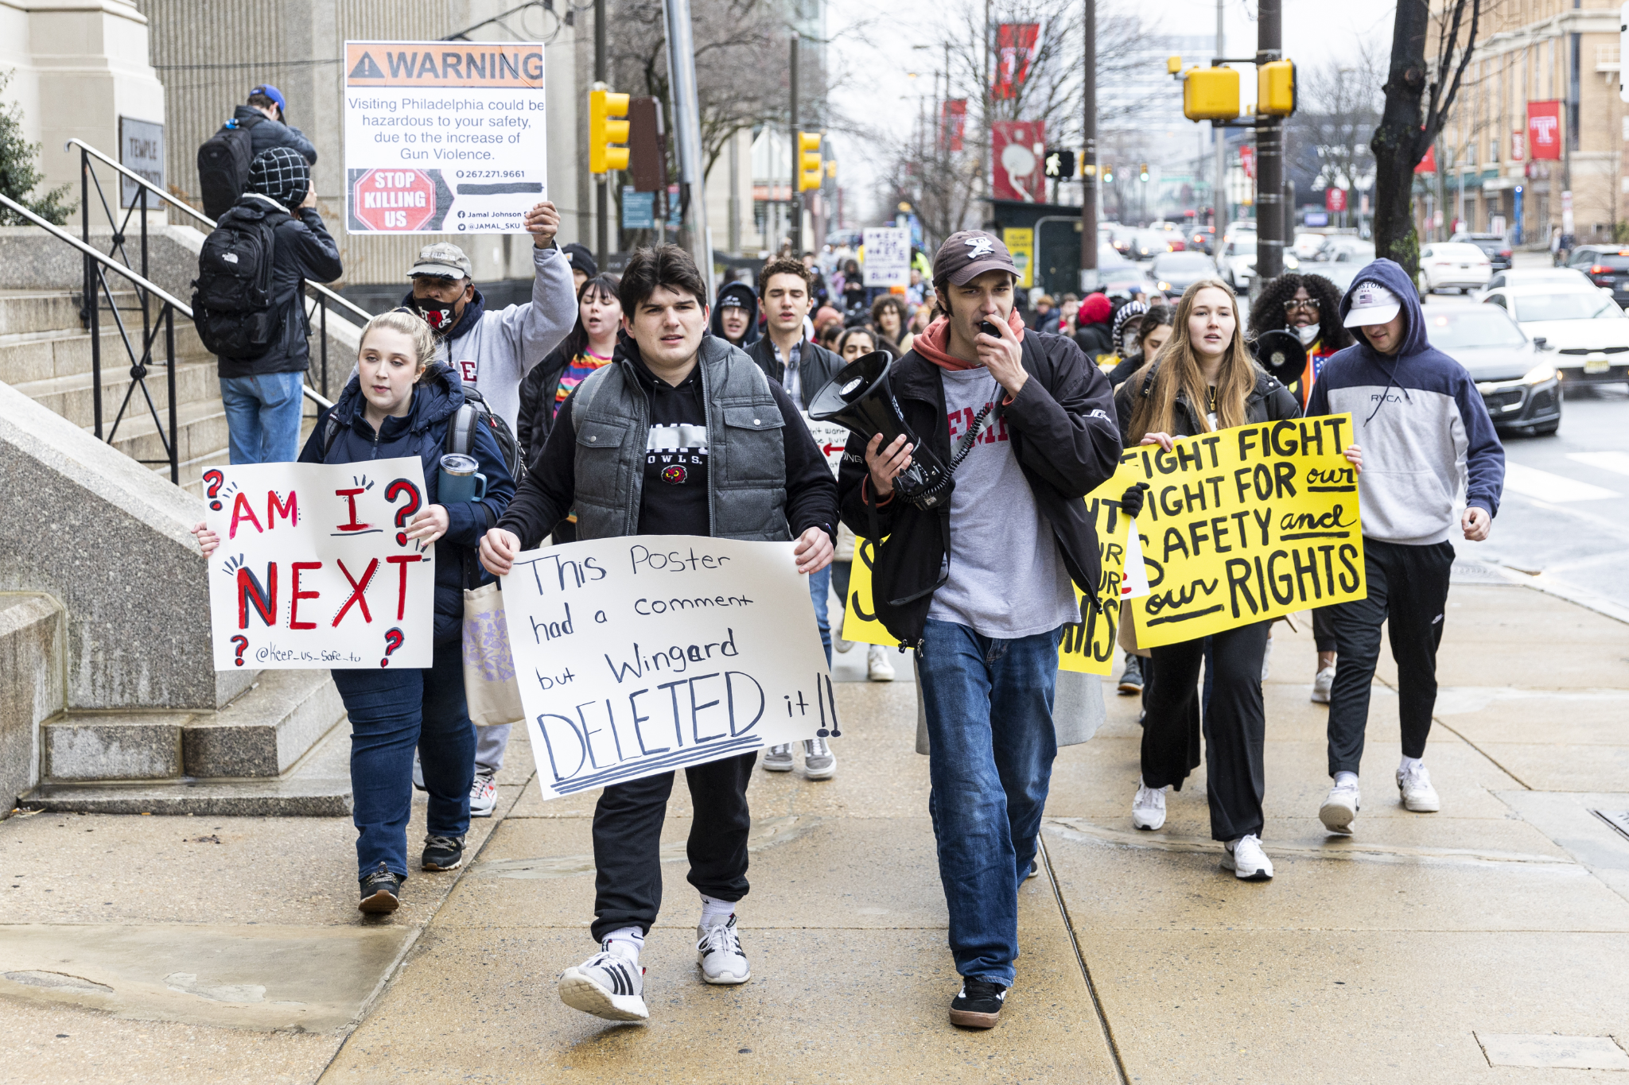

Temple students protest after the death of Officer Chris Fitzgerald—courtesy of the Philadelphia Inquirer.

**What can be done?**

The current state of campus safety may only partially result from increased crime in Philadelphia. Instead, the city's long-standing issues with crime may have spread to the Temple area in recent years. This raises even more questions: What factors are contributing to the problem? Could Temple have done more to improve the safety of the surrounding neighborhoods? Is there a lack of adequate police presence to deter criminal activity? Has the over-expansion of the school influenced crime in surrounding communities?

The common sentiment held among the Temple community is that Temple should be more involved in the crisis, whether through helping to build the community around them or working more cohesively with law enforcement. Professor David Mindich, chair of the journalism department at Temple, believes that strengthening the surrounding neighborhoods is critical in preventing crime and ensuring all areas of the school are safe.

*“I think there's plenty, but I think it goes down back to the root of the issue, which is that there should be jobs and housing opportunities for everybody around campus, and then in situations like that, crime typically goes down.”*

Professor Michael Hagen believes it is largely a funding issue and that a lack of money allocated toward security has inevitably led to a lack of patrols in some areas.

*“Well, having more patrols in the area is certainly a step in the right direction. Expanding the patrols and having fewer law enforcement folks walk around alone will help. After that, it's just going to require more money.”*

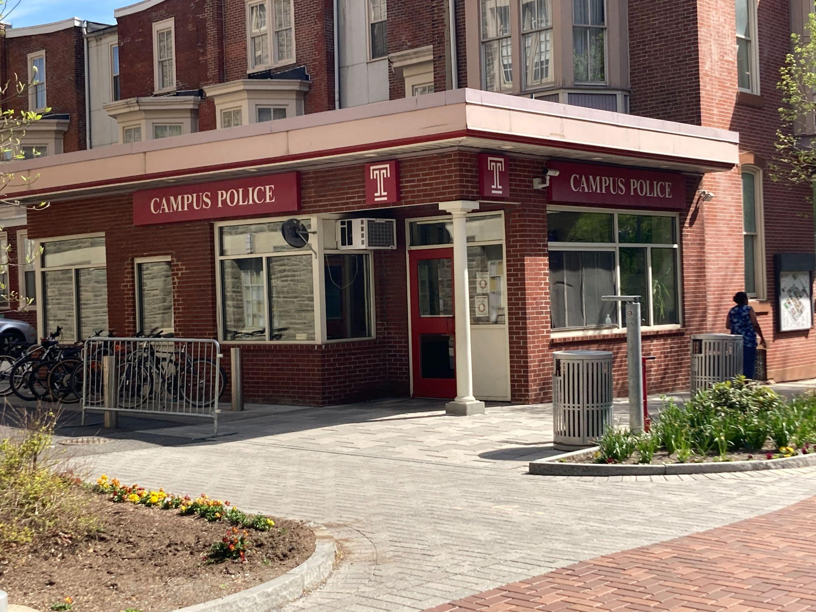

Temple University has grown too large for its own good, and the recent uptick in crime has only proven that the surrounding communities require attention and improvement. To address the issue of campus safety, it will be necessary for Temple to work collaboratively with law enforcement, local government, and community organizations.

This may involve investing in community development programs, increasing funding for security measures, and finding ways to alleviate overcrowding and other issues associated with the expansion of the university. Ultimately, the safety and well-being of students and staff at Temple will depend on a comprehensive approach that will take significant time and dedication from university staff and administration.

David DaCosta

Professor Atkins

JRN 3252

September 22nd, 2023

The Dangerous Game of Weight Cutting: Putting Athletes' Health First in Combat Sports

In the unforgiving arena of combat sports, where physical prowess and unyielding discipline are paramount, there exists a terrifying opponent that athletes must confront not in the ring or cage, but long before the first bell rings - the scale. It beckons with the promise of a tangible advantage, the chance to stand across from an opponent with a decided size advantage, but behind this allure lies a dangerous practice that can exact a devastating toll.

Weight cutting, on paper, is an extremely effective practice to give athletes an edge over the competition by competing at smaller weight classes, but its inherent risks and dire consequences must not be underestimated. It is imperative that we address the brutal reality of this practice, a dark underbelly that not only jeopardizes the health and well-being of our athletes but also tarnishes the very integrity of the pursuit of combat sports.

“It’s essentially sacrificing your body for a win, but half the time you're only going against other people who also cut, so it’s kind of just the standard at this point,” said Charley Mininger, a former wrestler for Archbishop Wood High School in a personal interview. “It’s honestly why I got out of the sport and focused on football, just because I wanted to be able to eat something in the winter.”

Weight cutting, in essence, is a process where athletes rapidly shed pounds in the days leading up to a competition, only to rehydrate and regain the weight just before they step into the ring, cage, or mat. This extreme manipulation of the body's natural weight can include intense dehydration, starvation, saunas, and even drug use– all in a bid to meet a specific weight class requirement. While this practice might provide a short-term competitive edge, it comes at an immense cost to the fighters' long-term health.

One of the most significant dangers of weight cutting is severe dehydration. Fighters often resort to sweating out excess fluids through prolonged sauna sessions or intense workouts, leaving their bodies in a severely dehydrated state. This not only poses an immediate threat to their health but also impairs their cognitive function and physical performance. A dehydrated fighter is more susceptible to injuries, heatstroke, and diminished decision-making abilities – a cocktail of risk factors that can turn a sporting event into a medical emergency. Moreover, weight cutting can result in electrolyte imbalances, which can lead to heart irregularities and other life-threatening conditions. The effects of rapid weight loss on the cardiovascular system can be catastrophic, and fighters have tragically lost their lives due to these extreme measures. It's an unacceptable price to pay for a competitive edge (National Library of Medicine, 2019).

This also has long-term consequences. Repeated episodes of extreme weight-cutting can cause lasting damage to a fighter's body. Kidney damage, hormonal imbalances, and even compromised bone density are among the potential long-term effects. These are not only detrimental to the fighters' overall health but also decrease the quality and duration of their careers (Los Angeles Times, 1986).

The combat sports community cannot turn a blind eye to these dangers any longer; we must prioritize the safety and well-being of our athletes over the superficial advantage of competing in a lower weight class. To address this issue, there are several critical steps that must be taken.

Firstly, implementing stricter weight management protocols is essential. Athletic commissions, governing bodies, and promotions must enforce stringent rules and regulations regarding weight cutting. This includes regular weigh-ins throughout the training camp, offering more weight classes, and imposing stricter monitoring of dehydration levels.

Furthermore, there should be increased medical oversight. Mandatory pre-fight medical evaluations should include assessments of a fighter's physical condition and hydration status. Competitions should not proceed if an athlete is in a sub-optimal state of health. This is actually starting to get put into practice, with major MMA promotion *ONE Championship* enforcing multiple hydration tests for every fighter prior to weighing in. If a fighter’s hydration level is “against policy” they are barred from competing and only make a certain percentage of their contractual purse, while the opponent will often be put up against a backup opponent or awarded full payment plus a win bonus. As well as this, they are very lenient regarding the rebooking of fights at a different weight to allow both opponents to healthily weigh in, with *ONE Championship* Vice President Rick Franklin saying in an interview for *MMania.com*: “We will not allow our athletes to compete dehydrated… But if they happen to be overweight, if they’re hydrated but maybe half a pound over or something like that, we can negotiate a catchweight. We have parameters for that” (Holland, 2017).

Finally, realistic weight class adjustments should be considered. This involves evaluating and potentially modifying weight classes to better reflect fighters' natural body weights. Doing so can reduce the incentive for drastic weight cutting, promoting healthier competition and safeguarding the well-being of combat sports athletes.

Weight cutting is a perilous practice that has no place in the modern world of combat sports. The dangers it poses to athletes' health and well-being far outweigh any perceived competitive advantage. The time has come for the combat sports community to take decisive action to eradicate this absurd regularity from our sport. We must prioritize the safety of our athletes and ensure that the integrity of combat sports remains intact.

David DaCosta

Professor Atkins

JRN 3252

November 11th, 2023

Led Zeppelin embarked on a relentless journey through their first half-dozen albums, leaving an indelible mark on the landscape of rock music. It’s difficult to talk about music in the early 70s without mentioning Led Zeppelin, with their unique twist of blues-rock and heavy metal taking the cultural zeitgeist by storm. By 1973, the band had already released four of the most critically acclaimed albums in rock n’ roll history with *Led Zeppelin I-IV;* and saw monumental success in their more experimental *Houses of the Holy* LP, where the band tinkered with a more psychedelic and lively production, stepping away from the niche blues band from London to legends of rock.

This prestige would only be bolstered in 1975, with the release of the band's first double album, *Physical Graffiti.* If Zeppelin was laying the foundation of their musical legacy with their earlier albums, *Physical Graffiti* was the edifice that showcased the band's maturity, versatility, and unrivaled command of their craft. The band had branched out and showcased multiple styles on their album in the past; the pairings of traditional folk and hard rock in *Led Zeppelin III* and masterful transitions between blues and metal in *Led Zeppelin II* had proven the band's appreciation for different styles, albeit often under the criticism of cultural appropriation. This, however, was the band's first effort to produce a record under their newly established *Swan Song* label, departing from *Atlantic Records* which had helped propel them to the prestige they had previously achieved. Regardless, *Physical Graffiti* somehow managed to blow the already high expectations out of the water for the band's first release in nearly three years, the longest hiatus the band had taken at the time.

The album has a number of hard-rock anthems that still hold up incredibly and are played on the radio, in public spaces, and at sporting events to this day, despite their raunchy attitudes and long runtimes. Songs like *Ten Years Gone* and *Kashmir* showcased the band's ability to create soundscapes and grandiose anthems with consistent but complex musical arrangements, while other tracks like *Trampled Under Foot* or *The Wanton Song* would bring the band back to their roots with tight, sharp riffs and steady, but intricate, beats by legendary drummer John Bonham.

Robert Plant, both from a writing and vocal standpoint, does a strong job of supporting the rest of the band's masterful production, but he seems to have taken a backseat in comparison to the command that he took in *Led Zeppelin IV* and *Houses of the Holy.* Despite being a longtime Zeppelin fan, I’m not too crazy about Plant’s vocals, so this wasn’t much of an issue for me, but it still should be noted that most songs on this LP, from a writing standpoint, don’t hold a candle to the band's previous lyrical masterpieces like *Stairway to Heaven* or *The Rain Song.*

Even so, the musical composition throughout the entire album, arranged by legendary guitarist Jimmy Page and musical virtuoso John Paul Jones stands the test of time as one of the most masterfully produced albums of the 20th century. No two songs are alike, with some coming with a complete orchestra and others simply featuring Page elegantly picking away at an acoustic guitar. John Bonham’s versatility comes through in spades, having to play multiple time signatures in various songs to back the already complex basslines of Jones and the riffs of Plant.

Really, the best way to describe the album is that there’s something in it for everybody, but the longer length of the album, not just in the tracklist but in overall song time, takes it to an entirely new level, making it an instant classic to nearly anyone who gives it a listen. There aren’t too many B-side tracks to speak of, not because they’re lackluster or underwhelming, but because they likely wouldn’t be considered “B-side” on any other album from any other band. Songs like *Down by the Seaside* and its beautiful, mellow aesthetic or *Bron-Yr-Aur* giving more light to the band's acoustic folk influences shouldn’t be relegated as weaker tracks because of their public reception at the time, but as testaments to the band's proficiency and versatility, particularly after a long layoff where they didn’t release any music, whatsoever.

Overall, there’s no real way to describe this album except as a culmination of Led Zeppelin’s musical evolution, a White Album of sorts, where the band was both at their creative height and the peak of their popularity. It’s poetic that such a culmination would be considered the band's last “great” album, with the following two albums, *Presence* and *In Through the Out Door* notably being underdeveloped and poorly received projects from a band well past their prime. *Physical Graffiti* stands as a testament to a band that not only shaped the course of rock music but, in their final flourish of musical excellence, left an indelible mark, solidifying their place as one of the greatest and most influential rock bands in history.

David DaCosta

Professor Atkins

JRN 3252

10/27/2023

If Temple Wants to Fix Their Enrollment Problem, They Need to Tackle Crime

Temple University has always been a highly-regarded academic institution in Philadelphia and has attracted high school graduates from the East Coast for almost a century. The school recently ranked [#89 on the U.S. News and Worlds Report](https://www.inquirer.com/education/temple-university-us-news-rankings-national-universities-20230918.html) and continues to excel in various academic fields, offering a diverse range of programs and opportunities for its students. As a vibrant hub of learning and innovation, Temple has fostered countless success stories and contributed significantly to the intellectual and cultural landscape of Philadelphia. So why did freshman enrollment drop by a staggering [20% in 2023](https://www.inquirer.com/education/temple-eastern-lasalle-enrollment-trends-20230924.html#:~:text=Temple%20saw%20one%20of%20the%20biggest%20drops&text=The%20school%20has%203%2C801%20freshmen,and%2054.4%25%20from%20fall%202019.)? If you’re a student at Temple or a member of the community, you know that there’s really only one issue that could trigger such a steep drop despite such strong performance from an academic standpoint: violent crime.

Despite its commitment to providing quality education, crime incidents on campus have become increasingly frequent and alarming, making it imperative for the university to address this issue before it further tarnishes its well-earned reputation. The Temple community has been increasingly impacted by the crisis, with the past year being marked by a number of tragedies either on or near campus. October of 2022 brought about the shooting and murder of [Everett Beauregard](https://6abc.com/everett-beauregard-murder-powelton-shooting-philly-police-35th-and-spring-garden-street/13798658/), a recent Temple graduate who intended to complete his master’s degree. Not even one month later, two [students were held at gunpoint and imprisoned in their basement at their off-campus home](https://abc7chicago.com/temple-university-robbery-home-invasion-students-robbed-philadelphia/12443885/#:~:text=The%20armed%20robbers%20proceeded%20to,PIN%20numbers%20and%20car%20keys.). February saw the tragic death of [Chris Fitzgerald](https://www.fox29.com/news/temple-university-police-sgt-chris-fitzgerald-to-be-laid-to-rest), a university police officer who was shot and killed by an 18-year-old visiting friends at the school. These incidents are just a few examples of the numerous violent crimes plaguing the university and its surrounding area, with hundreds of homicides, robberies, and shootings occurring within the past year.

Amid this rise in violent crime, concerns have grown within the Temple community about accountability to ensure the safety of students and staff. While the fault is not solely on the Temple administration, they have received the brunt of the blame for the issue, with many questioning their inability to tackle such a pervasive problem effectively. The crisis was a significant factor in the resignation of former university president Jason Wingard, who had been criticized for his [lack of action and attention to the issue](https://www.insidehighered.com/news/2023/03/29/temple-university-president-resigns#:~:text=Jason%20Wingard%20has%20stepped%20down,a%20tenure%20marked%20by%20controversy.). Despite Temple's implementation of various safety protocols and campus resources, such as walking escorts, emergency phones, and shuttle services, students still fall prey to robberies, assaults, and, tragically, murders on a semi-regular basis.

This raises some questions: How can Temple address this increase in violent crime, and have they been effective in handling it? The city of Philadelphia has implemented several [Gun Violence Intervention](https://www.inquirer.com/news/philadelphia-group-violence-intervention-guns-shootings-evaluation-20230228.html) programs and has attempted to strengthen law enforcement, despite recent [officer shortages](https://whyy.org/articles/philadelphia-police-department-academy-graduates-attrition-rates/). Unfortunately, however, violent crime is still on the rise, with the number of homicides in Philadelphia averaging over one a day since the beginning of 2023, according to the [Office of the City Controller](https://news.temple.edu/news/2023-09-22/remembering-president-joanne-epps).

Philadelphia has always grappled with issues of crime and poverty, much like any other major city in the United States. While these problems are not new, they have recently taken on a new dimension, significantly affecting the sense of security and well-being of those in the Temple community, as well as having a direct impact on student enrollment.

Long-time members of the Temple community agree that the situation has worsened, especially in the past five years. Candida Guerrero, an education major from the class of '96, believes that safety wasn’t a major concern during her time at Temple. However, the recent increase in crime has made her reconsider sending her children to study at the school.

“Over the years, as Philly, in general, has gotten less safe, I have less confidence that the campus is safe. Because of the increase in crime and the fact that you really never know what’s going on down there, I probably wouldn’t attend Temple now, and I’m not really comfortable sending my kids there either.”

Professor Michael Hagen, a politics professor at Temple for 20 years, holds similar sentiments. In a personal interview, he talked about the state of campus safety and the measures Temple has taken to fix it. However, he sees the issue as a relatively recent phenomenon that could threaten enrollment at the school.

“It certainly seems less safe than it was five years ago. It was considerably safer 15 years before that, so the security ebbs and flows, and we’re definitely at an ebb. The university has to handle it because it's definitely part of the recent drop in enrollment, I mean. I could see why suburban high school kids are hesitant to come.”

Former Philadelphia police officer and retired homicide detective Brady Barker sees it differently, however, holding a glimmer of hope that the problems in Philadelphia, and in turn Temple’s campus, are starting to take a turn for the better. In a personal interview at Balance MMA and Fitness, he told me:

“Now listen I’m not saying it’s all ‘kumbaya’ and peaceful down there, or anything like that at all. But it really seems like it's calmed down a bit over the summer, in North Philly at least, with the shootings and the robberies. At least that’s how it feels talking to friends who are still working and watching the news. But yeah, the school can always do more to try and prevent any incidents. More patrols, less dimly lit areas, that kind of stuff”

Nevertheless, it remains abundantly clear that something needs to be done in order to stop incoming freshmen from being too afraid to attend such an established and culturally vibrant institution. The crisis is only bolstered by the untimely death of university president [Joanne Epps](https://news.temple.edu/news/2023-09-22/remembering-president-joanne-epps), however, there’s always a glimmer of hope that the reappointment of Richard Englert could pave the way for new strides in making the campus a safer place. For now, however, the main priority of the school should be to help protect their students and local community, whether that be through working more extensively with law enforcement or the local communities surrounding the school.

David DaCosta

Professor Atkins

JRN 3252

December 1st, 2023

If Charelle Parker Wants Change, She Needs to Address the Fentanyl Crisis

The City of Philadelphia made history this month by electing Charelle Parker as mayor, becoming the first woman to ever hold such a position of power in our city. The mayor-elect seems to be a breath of fresh air from the Kenney administration, promising to combat crime and strengthen our schools; but there’s still a looming threat that directly influences both issues. As we move forward with this new administration, it's crucial that we seize the opportunity to address a pressing issue that has silently plagued our communities—the fentanyl crisis.

In 2022, the Philadelphia Department of Public Health recorded 1,413 unintentional overdose deaths, an 11% increase from the previous record in 2021 (City of Philadelphia). Almost anyone living in the city has been or knows someone who’s been directly affected by the crisis, and the urgency to confront it has never been more apparent. The drug crisis is a relentless force that transcends socioeconomic boundaries, leaving behind only tragedy and ruined neighborhoods.

This is only bolstered by the proliferation of fentanyl and a new drug called xylazine that has been exponentially increasing overdose death rates. Xylazine, otherwise known as “tranq”, is a horse tranquilizer that has often been cut into common street drugs like heroin and PCP. This, in unison with the already dangerous synthetic opioid fentanyl, exponentially increases the death rate of overdoses, and because of the fact that it’s technically not an opioid, common anti-overdose measures like Narcan do nothing to treat it.

This makes it critical for this new administration to approach the drug crisis with more sensitivity than ever before, and the citizens of Philadelphia agree as well. A 2023 Lenfest poll showed that over 50% of Philadelphians viewed the opioid crisis as the most significant issue on the ballot. Of those surveyed, only 22% saw arrests as a viable way to combat the issue and well over 60% saw treatment and mental health services as effective tools, proving distrust in the traditional "war on drugs" approach to drug crime (Philadelphia Inquirer). The sentiment among Philadelphians signals a collective desire for a more compassionate and nuanced strategy, recognizing that the opioid crisis is not merely a criminal issue but a complex public health challenge.

Safe injection sites, controversial as they may be, have emerged as a potential lifeline in other cities grappling with similar challenges. These sites not only provide a supervised space for drug use but also serve as entry points for individuals to access critical health services and addiction treatment. It's a pragmatic and compassionate response to an issue that demands innovative solutions. Not only that but, contrary to popular belief, no evidence has shown an uptick in overdoses or drug use in neighborhoods with safe injection sites.

Safe injection sites are one of the only surefire ways to prevent tranq and fentanyl overdoses in the city and would not only be a critical step in combating the drug crisis but would potentially save thousands of lives in the process. As the Parker administration takes office, it's imperative that they consider strengthening and expanding the safe injection facilities and mental health services of the city, as the current drugs on the market only get stronger and more addictive every year.

David DaCosta

Bodylock MMA

Cody Garbrandt: The Rise and Fall of a Former Champion

If you were to ask the average MMA fan in January of 2017, shortly after Cody Garbrandt had put together what was arguably the most outstanding title performance we had seen in the UFC against the former king of the division Dominick Cruz, how long they thought he’d reign as champion, it’s very likely that some would say he’d retire undefeated. Up until that point, the rising star had mostly looked invincible, having an undefeated record against great stars of the bantamweight division like the former rising star Thomas Almeida, Takeya Mizugaki, and the seemingly-invincible Dominick Cruz. The highlight reel fighter had become one of the youngest champions of all time at 27 years old with a meteoric rise to title contention, backed by some of the most excellent boxing in the UFC and solid grappling to back it.

Fast forward six years, and he’s become an afterthought of the division. More skilled strikers like Sean O’Malley, Cory Sandhagen, Marlon Vera, and Petr Yan have appeared to lap him, and dangerous grapplers like current champion Aljamain Sterling and Merab Dvalishvilli never had to deal with him in the first place. People who have beaten him, albeit not without some trouble, like Pedro Munhoz and Rob Font have fallen out of the top five of the division, and, in Garbrandt’s first attempt to compete at flyweight, he was knocked out in the first round against the rising star in Kai Kara-France. So the question has been raised to a large portion of the fanbase: What’s happened to one of the most fascinating fighters to watch on the roster?

Following his win against Dominick Cruz, Garbrandt was pitted against his former teammate and rival T.J. Dillashaw in an extremely anticipated fight. He actually looked fairly great in this fight, knocking Dillashaw down in the first and putting him on shaky legs. However, the second round of this bout revealed one of the biggest deficits in Cody’s game, his unwillingness to leave the pocket. Cody and T.J. entered the pocket to trade and it only took one sharp right hook and some follow-up shots for the air of invincibility in Garbrandt’s striking to dissipate.

Cody got an immediate rematch after this, given the drama between the two fighters and the fact that the first fight was a major success for the promotion. This fight largely went the same, with the only differences being that Garbrandt scored zero knockdowns and was finished in the first round rather than the second.

Garbrandt took almost a year off after this, and rightfully so. The young fighter had fought eight times in under three years since he had entered the UFC and would get booked opposite of the at-the-time rising star Pedro Munhoz to open the UFC 235 main card. Garbrandt was looking like his old self for the majority of the first round, firing solid low kicks and using crisp head movement to shoot sharp jabs and hooks. However, old habits die hard, and Garbrandt eventually found himself in the pocket, yet again, trading hook after hook with a fighter known for his more than capable chin. By the end of the round, Garbrandt had been dropped by a right hand, with Marc Goddard stepping in to end the fight.

It was at this point that fans began to worry about Garbrandt. There have been far too many cases like that of Chuck Liddell, Renan Barao, and Johnny Hendricks that told the story of fighters with meteoric rises to stardom only to fall once their chins had faded. Cody was starting to look like one of these stars, and so the matchmaking at the UFC had to be careful in who they paired him up against next.

After over a year-long layoff, Garbrandt found himself in one of the first post-pandemic fight cards at UFC 250, this time against a fellow star of the same era, Raphael Assuncao. The two had come off of a combined five consecutive losses and so the fight made a lot of sense from a matchmaking standpoint. Garbrandt once again looked like his old self in this fight, landing sharp low kicks and putting his boxing to good work. He danced around the cage with phenomenal footwork to avoid the threat of the takedown and, eventually in the second round, knocked Assuncao out with a single right hand at the buzzer, almost out of a movie. Up until that point, Assuncao had only been knocked out once in 2011, so in a lot of ways this fight showed that Garbrandt still had dynamite in his hands and could still hang with the top tiers of the division, as long as he stayed defensively responsible. In short, Garbrandt was back with a bang.

That was until a year later when he was put back into a main event spot against Rob Font. Garbrandt didn’t even look bad in this fight, showing some of his wrestling background by trying to take Font to the canvas and winning the first round. I’d be lying if I said that he wasn’t outclassed though. Whether it was Font’s granite chin, which would later get proven in his next bouts against Jose Aldo and Marlon Vera, or his boxing style fundamentally being a strong counter against Cody, Garbrandt just didn’t look himself in this fight, eventually being beaten in a unanimous 49-46 decision.

It was at this point that most fans came to the cruel acceptance that Garbrandt simply wasn’t cut out to be a contender in the division that he had previously looked invincible. Font was no slouch, but from an X’s and O’s standpoint, it was Garbrandt’s kind of fight: a striker with limited power who didn’t like to sit in the pocket, but even that proved to be difficult for the former champion. Cody’s career was largely up in the air at this point. The matchmakers had given him multiple chances to remain in the top five of the division, but too many rising stars were entering their prime and Cody’s lack of wins against top contenders essentially forced him out of the top ten. Something needed to change, which made his next career choice understandable to most fans.

In what seemed like a sudden move to flyweight, Garbrandt was paired up against the always-game Kai Kara-France, a young and powerful striker who had a slow but noticeable rise to the top of the flyweight division. A win would certainly put Garbrandt into the title picture of flyweight and bring his prestige to new and old fans alike. He was always a fairly small bantamweight and so the move felt like a natural progression in his career. After making weight and having a good exchange with Sean O’Malley, a bantamweight contender with a rise similar to Garbrandt, he entered the cage opposite of Kara-France. However, the fight didn’t go as many fans expected.

This was likely the most depressing bout to view as someone who watched the rise of the former champion, as Kara-France largely made short work of Garbrandt, knocking him out in the first round. I wish I could say that Garbrandt looked good in this bout but, in reality, he didn’t. He was outclassed in every aspect of the fight, taking heavy blow after heavy blow until Herb Dean was forced to stop the fight. Garbrandt’s career, at this point, was largely in the hands of the UFC brass, having lost most of his negotiating leverage and star power.

And that brings us to the modern day leading up to UFC 285, where Garbrandt appears on the prelims for the first time since 2015, against a relative no-name in Trevin Jones. With a loss, it is very likely that the former champion will hang up his gloves and move on to different endeavors like boxing or coaching. However, the more interesting question is: What happens if he wins? What place does Garbrandt have in a division filled with some of the best fighters in the sport? Given his recent record, how many fights is he away from getting back into the title picture; that is, if he ever makes it to that point? He’s only 31 years old, which is relatively young for the UFC with champions like Glover Texeira gaining the title well past his athletic prime, and still has time to put together a solid win streak.

As, someone who’s grown up watching Cody, and even rooting for him despite the fact that he outclassed my favorite fighter at the time, Dominick Cruz, a part of me wants him to win. A part of me wants him to put forward a striking masterclass, once again, and show the world how exciting his style could be. But, with that in mind, what’s the point if he does? Even if he gets past Jones and puts together a decent win streak, I still don’t think that he could hang in the upper echelons of the current bantamweight division. If small fighters like Kai Kara-France could knock him out and inconsistent fighters like Rob Font could cruise to win a decision against him, who’s to say what a terminator like Cory Sandhagen or Marlon Vera could do to him, or how much the grinders of the division like Merab Dvalishvili could make him look like an amateur.

In my opinion, Garbrandt’s rise and fall is a great allegory for the current change of the guard within the UFC. If you were to look at the champions who reigned alongside Garbrandt at the time; Miesha Tate, Jose Aldo, Eddie Alvarez, Tyron Woodley, Michael Bisping, etc. all of them have either retired by now or moved onto different things, with the only exceptions being Max Holloway and Jon Jones.

The main difference between Garbrandt and these former champions, however, is that Garbrandt is still only 31 years old. On paper, without considering the knockouts he’s been put through, he’s one of the only athletes in his division still in his athletic prime and has plenty of potential. However, I believe that the skill gap in this new generation of fighters could leave Garbrandt in the dust, and this next fight against Trevin Jones will prove if he still has the mental and physical faculties to still hang in the sport, let alone compete against the savages far ahead of him in the current rankings.

Cody Garbrandt vs. Trevin Jones will feature on the UFC 285 preliminary card. Order the UFC 285 PPV event on ESPN+ to watch every fight live on Saturday, March 4.